Forecasting Air Quality Using Historical Pollution Data

Project Statement

Air pollution is a growing concern in urban environments, directly impacting human health and environmental quality. Accurate forecasting of air quality can help authorities take preventive measures, issue warnings, and inform the public. This project aims to build a time series forecasting system that predicts air quality index (AQI) and pollutant levels using historical pollution data. The goal is to empower environmental agencies, city planners, and the public with timely insights for healthier decision-making

Purpose
The purpose of this project is to develop an intelligent air quality forecasting system that predicts the Air Quality Index (AQI) and pollutant concentrations using historical environmental data. By leveraging time series analysis and machine learning models, the project aims to provide early warnings of poor air quality, enabling timely intervention and informed decision-making by government authorities, environmental agencies, and the general public.

Tools & technologies implemented
Programming Languages : Python
Libraries & Frameworks :
Pandas, NumPy – For data cleaning, transformation, and analysis.
Matplotlib, Seaborn, Plotly – For interactive data visualization and trend analysis.
Scikit-learn – For feature engineering, model evaluation, and performance metrics.
Statsmodels (ARIMA) – For classical time series modeling and forecasting.
Prophet – For seasonality-based forecasting and trend detection.
TensorFlow / Keras (LSTM) – For deep learning-based AQI and pollutant forecast.
Streamlit – To build an interactive web-based dashboard for real-time AQI
Development Tools :
Google Colab – For data exploration, model training, and experimentation.
Visual Studio Code (VS Code) – For dashboard development and code integration.
Deployment & Integration :
Streamlit Cloud / Localhost – For running and hosting the interactive AQI dashboard.
Ngrok (optional) – For sharing Streamlit apps publicly during testing.
Dataset :City_day.csv (Air Quality Data) – Contains daily pollutant concentrations (PM2.5, PM10, NO2, SO2, CO, O3, etc.) used for training forecasting models and visual analytics.

What is AQI (Air Quality Index)
The Air Quality Index (AQI) is a standardized system used to measure and report the quality of air in a specific area. It provides a single numerical value that indicates how clean or polluted the air is and what associated health effects might be of concern to the public.
The AQI converts complex air pollutant data into a simple scale ranging from 0 to 500, where:
0–50 → Good (Air quality is satisfactory)
51–100 → Moderate (Acceptable but some pollutants may be a concern for sensitive people)
101–200 → Unhealthy for sensitive groups
201–300 → Very Unhealthy
301–500 → Hazardous
Factors Affecting AQI
The AQI is determined based on the concentration of several key air pollutants known to affect human health and the environment. The main pollutants are:
Carbon Monoxide (CO): Produced from incomplete combustion of fossil fuels; affects oxygen delivery in the blood.
Sulphur Dioxide (SO₂): Emitted from burning coal and oil; causes respiratory problems and acid rain.
Nitrogen Dioxide (NO₂): Formed from vehicle exhaust and industrial emissions; irritates airways and contributes to smog.
Ammonia (NH₃): Released from fertilizers, livestock waste, and industrial sources; affects the respiratory system.
Particulate Matter (PM2.5 & PM10): Tiny dust and soot particles that can penetrate lungs and bloodstream.
Ozone (O₃): A secondary pollutant formed by reactions between NO₂ and volatile organic compounds under sunlight; causes breathing difficulties.
How to Measure These Factors
Each pollutant is measured using specific sensors and instruments that detect their concentration in the air (usually in micrograms per cubic meter – µg/m³ or parts per million – ppm):

Pollutant | Measurement Method | Instrument Used
PM2.5 / PM10 | Gravimetric method or Laser Scattering | Air Quality Monitor, Beta Attenuation Monitor
CO (Carbon Monoxide) | Non-Dispersive Infrared (NDIR) Method | CO Analyzer
SO₂ (Sulphur Dioxide) | UV Fluorescence Method | SO₂ Analyzer
NO₂ (Nitrogen Dioxide) | Chemiluminescence Method | NOx Analyzer
O₃ (Ozone) | UV Photometric Method | Ozone Analyzer
NH₃ (Ammonia) | Chemiluminescence / Ion Selective Electrode | NH₃ Analyzer
Pb (Lead) | Atomic Absorption Spectroscopy | High-Volume Sampler

Agencies / Apps That Provide AQI Information
Several governmental and private organizations monitor air quality and provide real-time AQI updates through websites and mobile applications:

Agency / Platform | Region / Authority | Purpose / Application
Central Pollution Control Board (CPCB) | India | Operates National Air Quality Monitoring Programme (NAQMP Dashboard)
SAFAR (System of Air Quality and Weather Forecasting And Research) | India (IMD & MoES) | Provides AQI forecasts for major Indian cities
U.S. Environmental Protection Agency (EPA) | USA | AirNow website and app for real-time AQI data
World Air Quality Index (WAQI) | Global | https://waqi.info/ – Global real-time AQI visualization
IQAir / AirVisual | Global | Mobile app and sensors showing real-time AQI and forecasts
BreezoMeter | Global | Provides location-based air quality insights and health alerts

Importance of AQI Monitoring
Monitoring AQI helps:
Protect public health by issuing early alerts.
Guide environmental policy and urban planning.
Enable public awareness about pollution exposure.
Support research and forecasting models for sustainable development.

Solutions and Preventive Measures for Air Pollution
1.Technological Solutions
Modern technology plays a vital role in reducing and managing air pollution. Some key innovations include:
- Air Purifiers: Devices that filter pollutants like PM2.5, dust, smoke, and allergens from indoor air. Commonly use HEPA and activated carbon filters to improve indoor air quality.
- Industrial Filters & Scrubbers: Factories and power plants can install electrostatic precipitators, scrubbers, and catalytic converters to minimize harmful emissions.
- Electric & Hybrid Vehicles: Promoting electric mobility reduces carbon monoxide and nitrogen oxide emissions from traditional fuel-based engines.
- Renewable Energy: Using solar, wind, and hydro power instead of coal or oil-based sources significantly cuts down air pollution and greenhouse gases.
2.Individual / Household Measures
Individuals can contribute greatly by adopting eco-friendly habits:
- Avoid open burning of waste and minimize the use of wood or coal stoves.
- Carpool, cycle, or use public transport instead of driving alone.
- Maintain vehicles regularly to reduce exhaust emissions.
- Conserve energy by switching off lights and appliances when not in use.

Coding Details:
1 Tools, Technologies, and Software Used

Programming Language | Python | Core programming for data preprocessing, model building, and visualization
Libraries & Frameworks | Pandas, NumPy | Data cleaning, handling missing values, feature engineering
 | Matplotlib, Seaborn, Plotly | Visualization of pollutant trends and AQI distribution
 | Scikit-learn | Data transformation, model evaluation (RMSE, MAE)
 | Statsmodels (ARIMA) | Classical time series forecasting
 | Prophet | Forecasting pollutant trends with seasonality
 | TensorFlow / Keras (LSTM) | Deep learning-based air quality forecasting
 | Streamlit | Interactive web dashboard for visualization and user interaction
Software / IDEs | Jupyter Notebook / Google Colab | Model development and testing
 | Visual Studio Code (VS Code) | Streamlit dashboard development and integration
Version Control | Git / GitHub | Optional – for saving and managing project versions
Deployment / Visualization | Streamlit Cloud / Localhost | Hosting the interactive dashboard

2.Project Diagram

┌──────────────────────────┐
│ Data Collection │
│ (City_day.csv Dataset) │
└────────────┬─────────────┘
│
▼
┌──────────────────────────┐
│ Data Preprocessing & EDA │
│ (Cleaning, Feature Engg.)│
└────────────┬─────────────┘
│
▼
┌──────────────────────────┐
│ Model Training & Eval │
│ (ARIMA / Prophet / LSTM) │
└────────────┬─────────────┘
│
▼
┌──────────────────────────┐
│ Alert Logic & Visualization │
│ (Trend, AQI Risk, Reports) │
└────────────┬─────────────┘
│
▼
┌──────────────────────────┐
│ Streamlit Web Dashboard │
│ (User Interface Layer) │
└──────────────────────────┘

- Description of Each Module
Milestone 1 – Data Preprocessing & EDA: Loads the air quality dataset, handles missing values, normalizes features, and visualizes pollutant correlations.
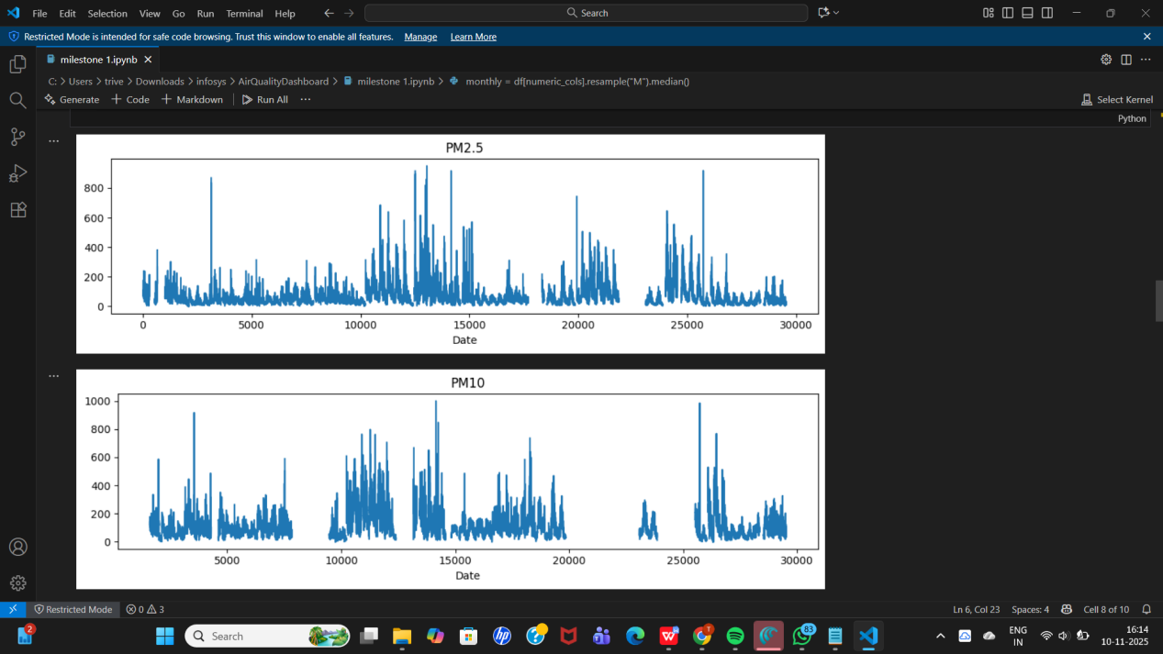
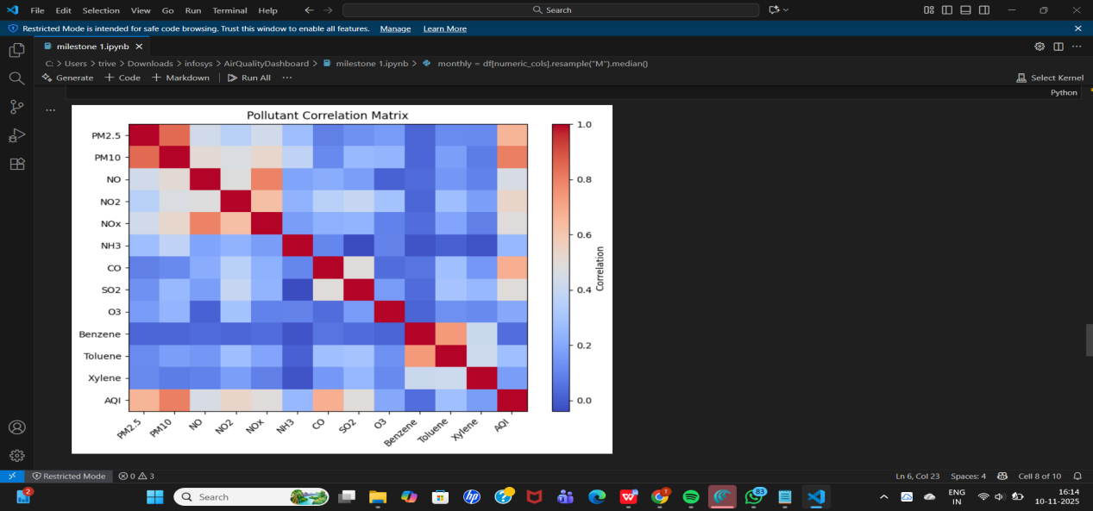

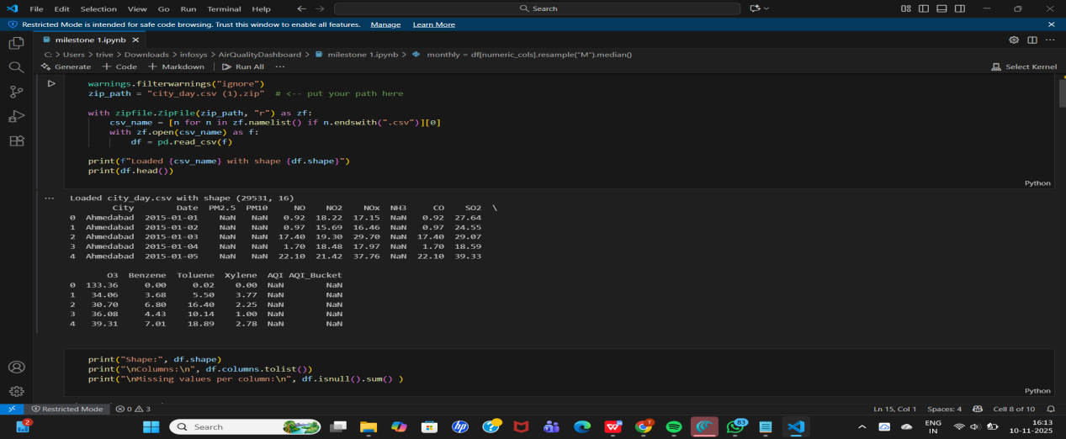

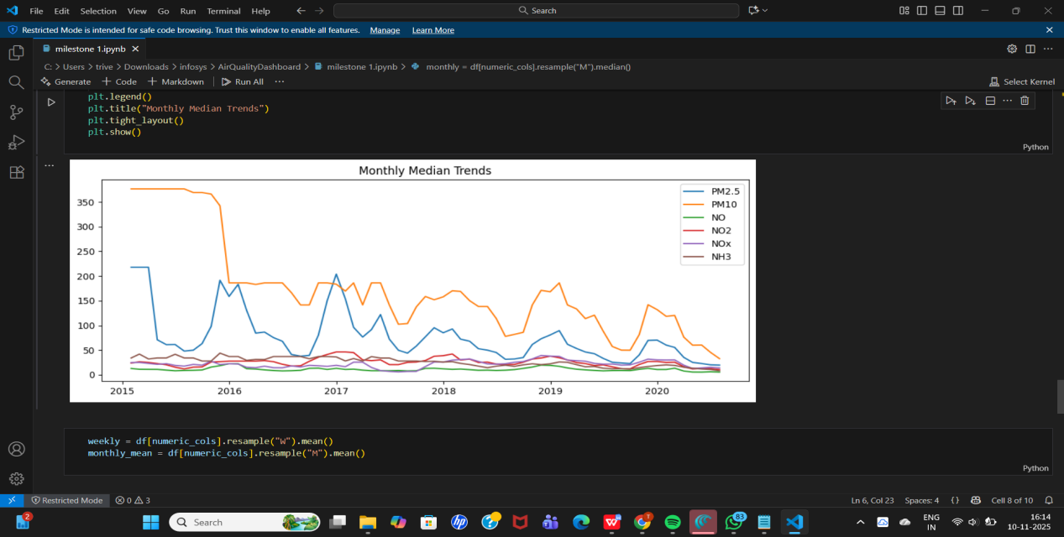

Milestone 2 – Model Training & Evaluation: Applies ARIMA, Prophet, and LSTM forecasting models; evaluates results using RMSE and MAE; selects the best-performing model.

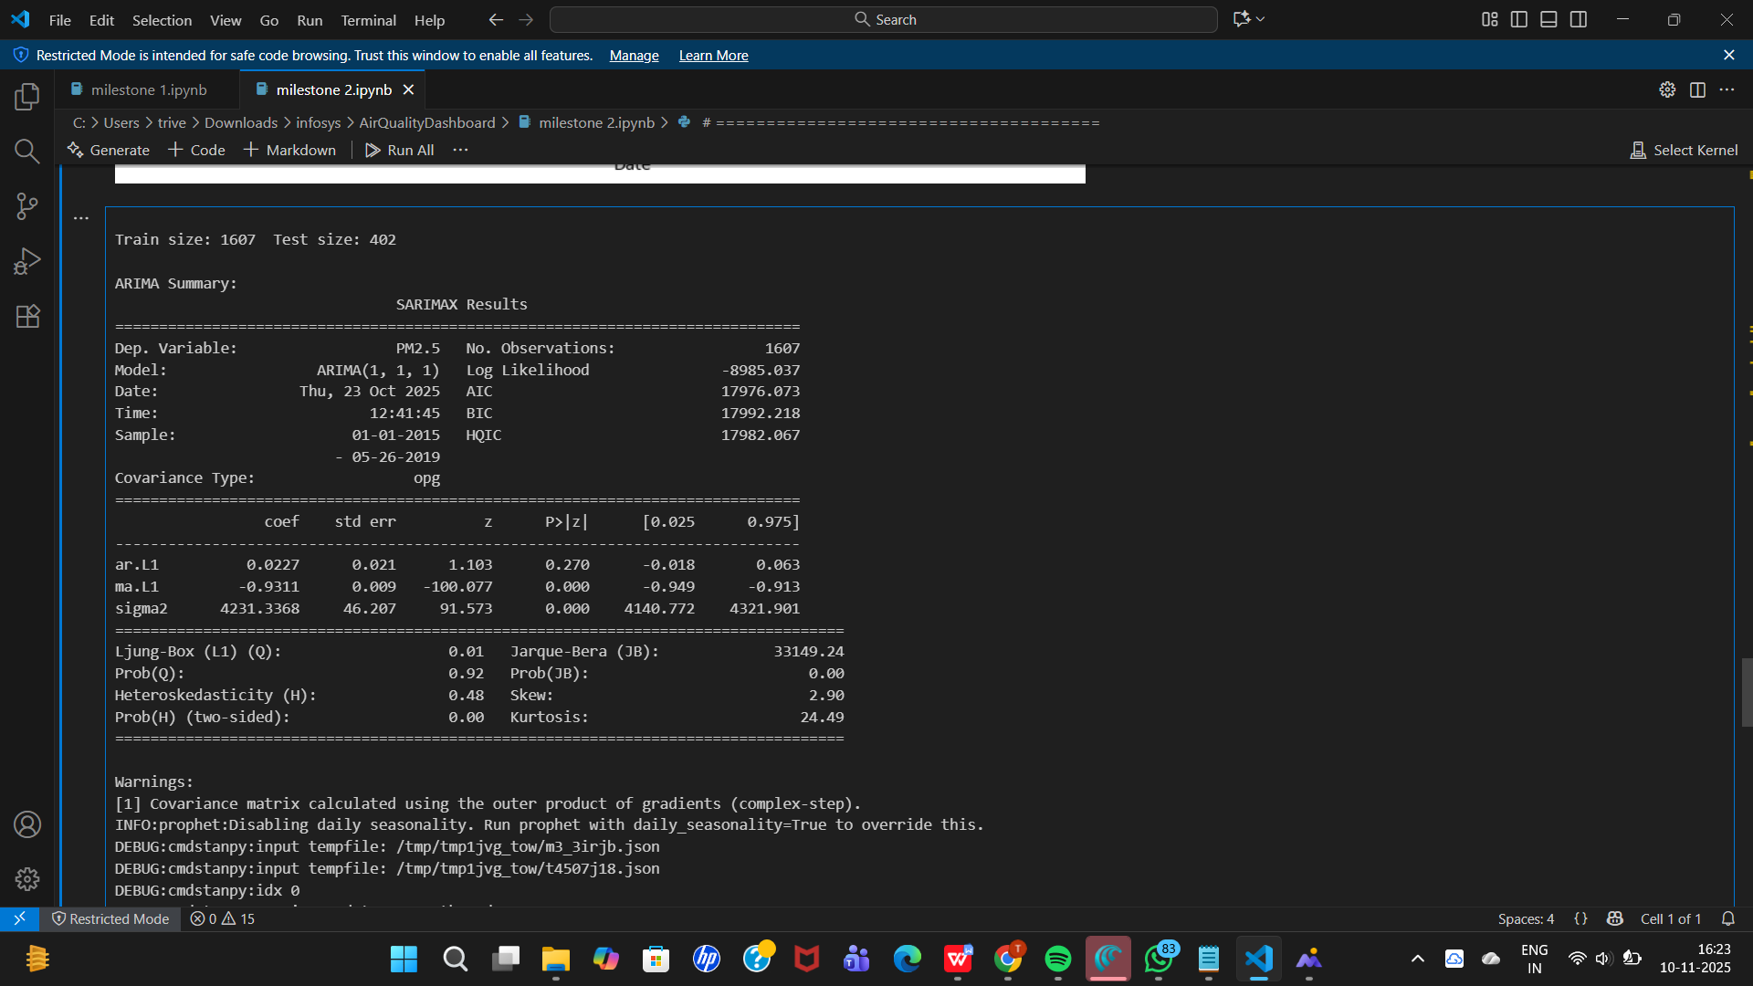

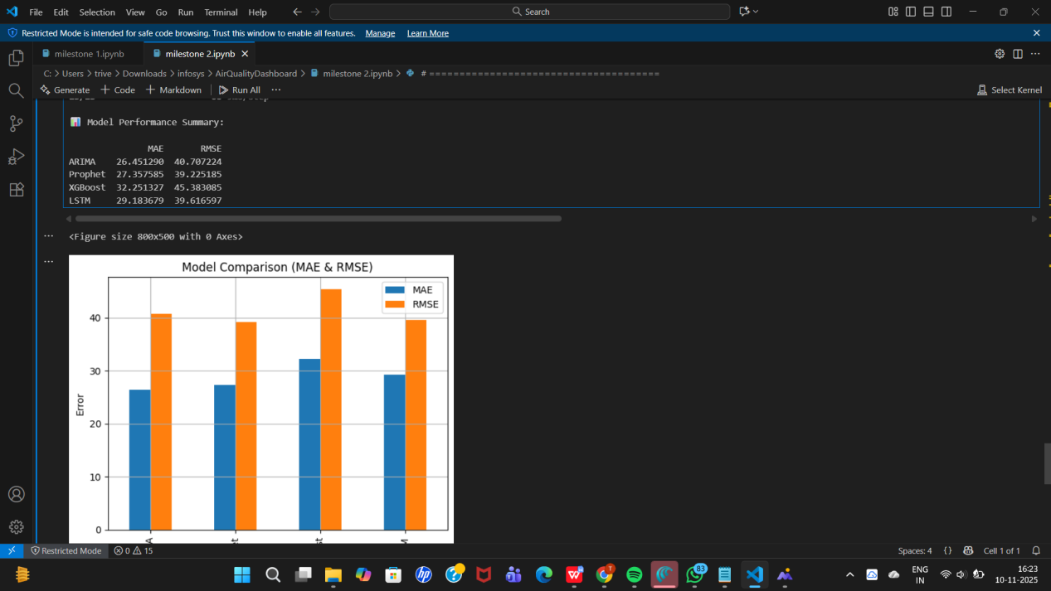
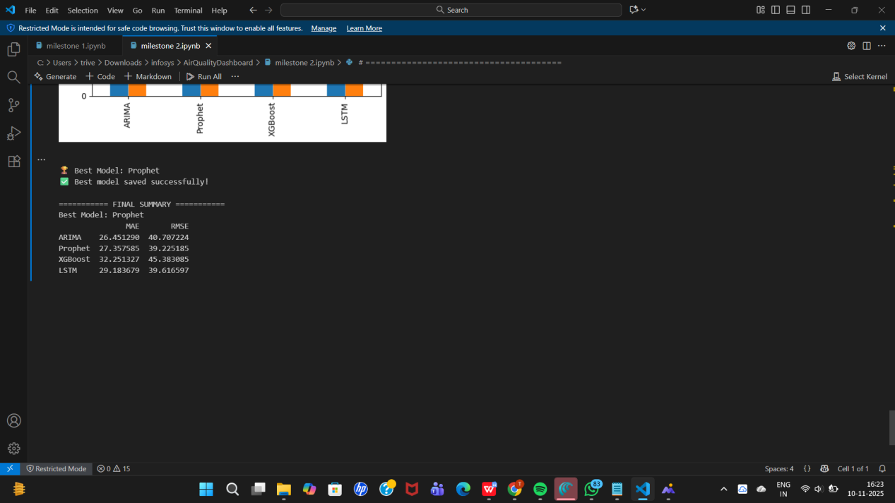

Milestone 3 – Alert Logic & Trend Visualization: Defines AQI thresholds, identifies high-risk days, and visualizes forecast trends.
STEPS TO RUN THIS CODE:
- Copy the full code into a file named aqi_dashboard.html.
- Open it in any browser (no Python or server needed).
- Choose:
I.City
II.Date range
III.AQI Type (e.g., PM2.5)
- Click Show Report → it displays:
I.The latest AQI value
II.Color-coded alert message
III.7-day AQI forecast chart

OUTPUT:

OUTPUT:
Outputs: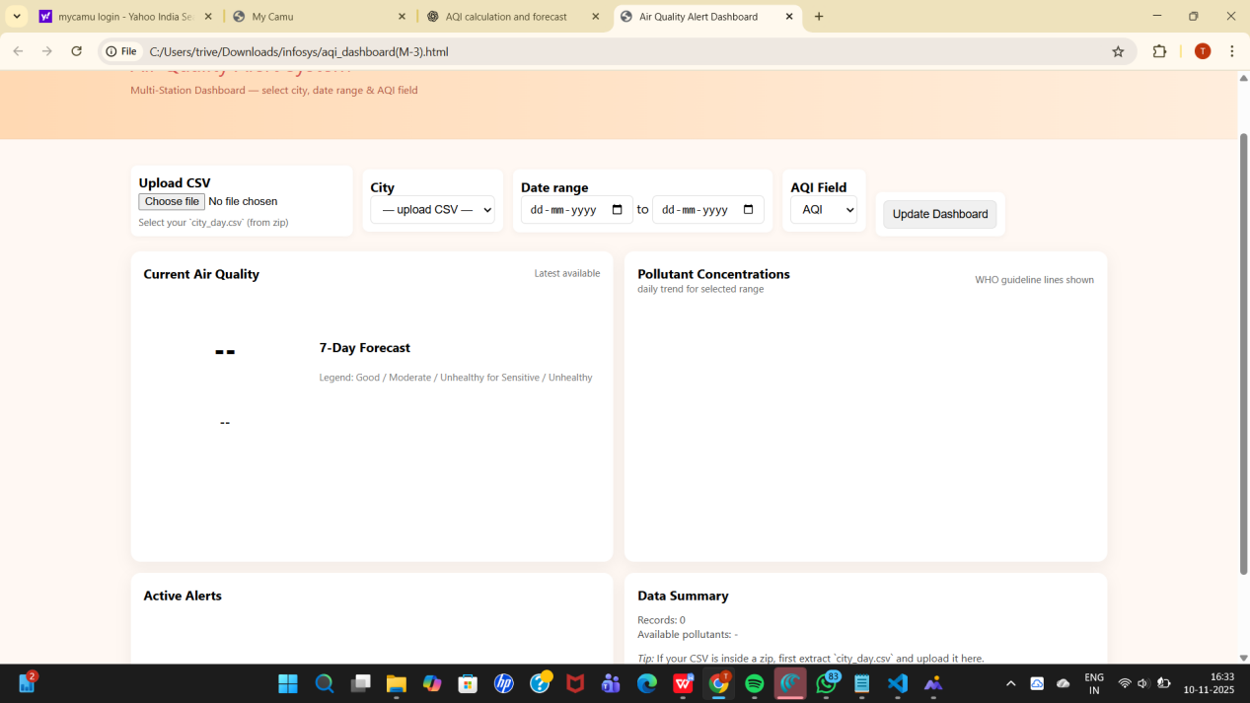

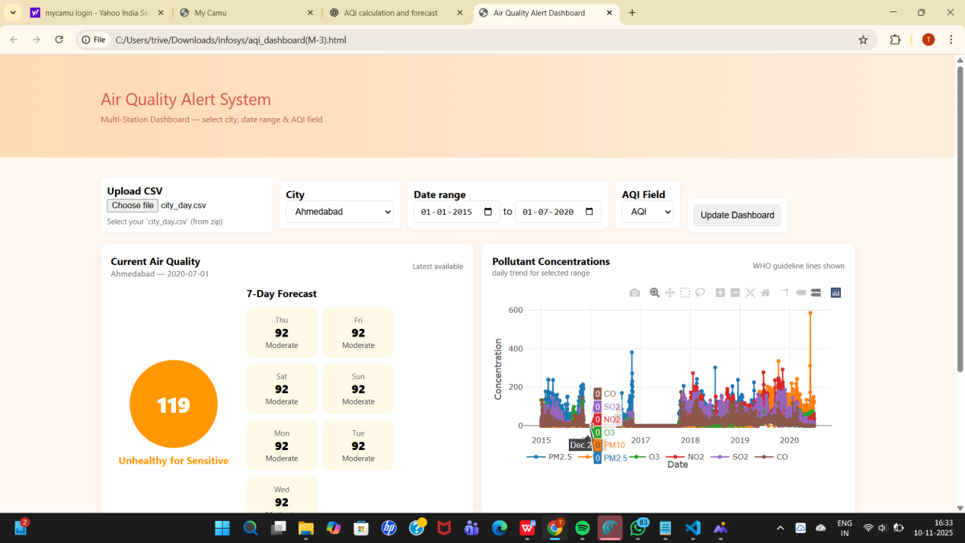
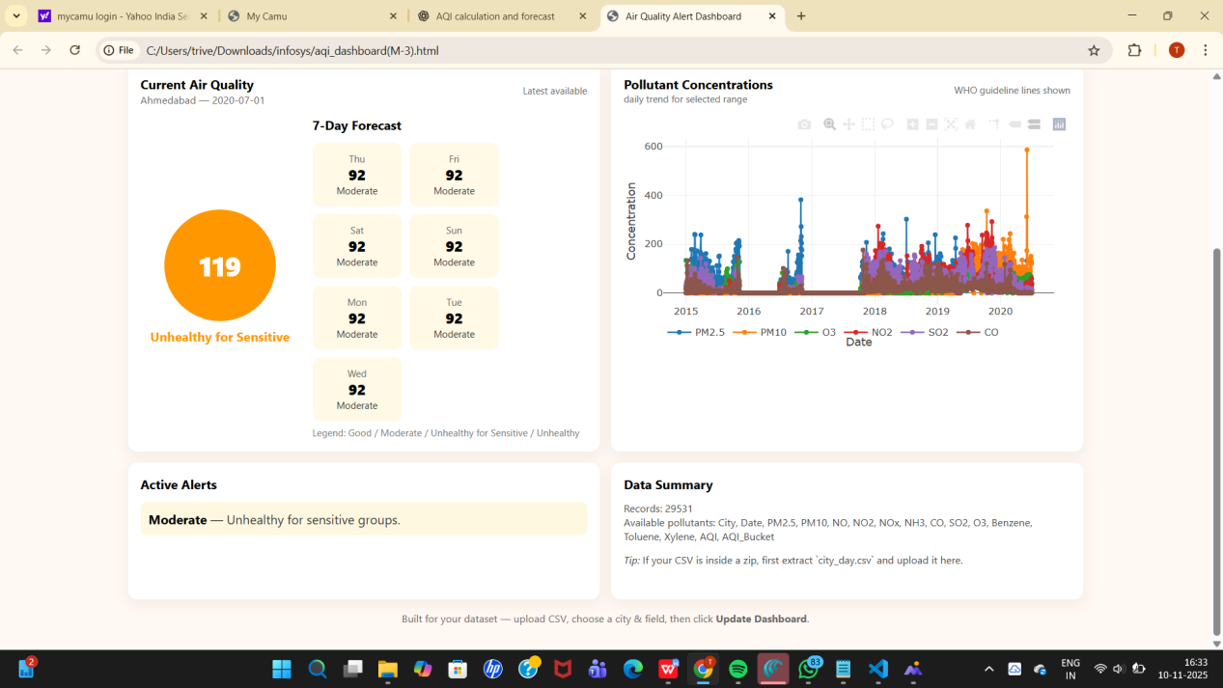

Milestone 4 – Streamlit Dashboard: Integrates all models and results into an interactive web app that allows users to select city, pollutant, and timeframe; displays AQI gauge, charts, and alerts.

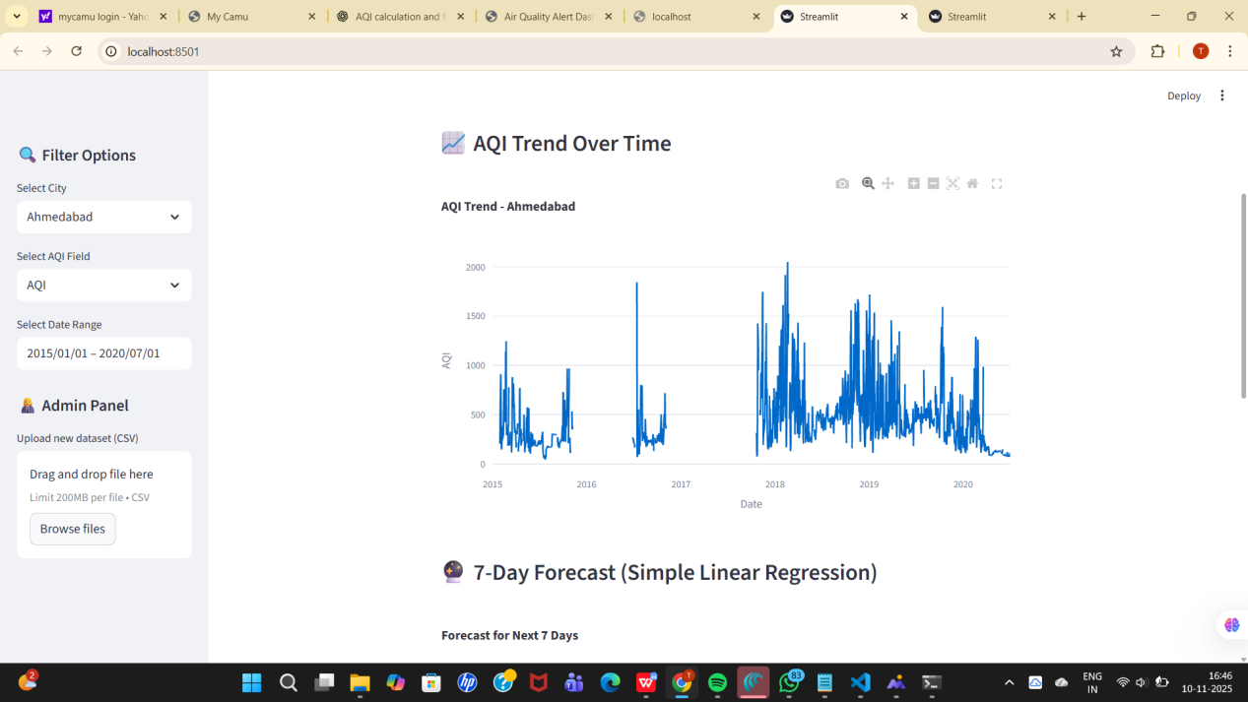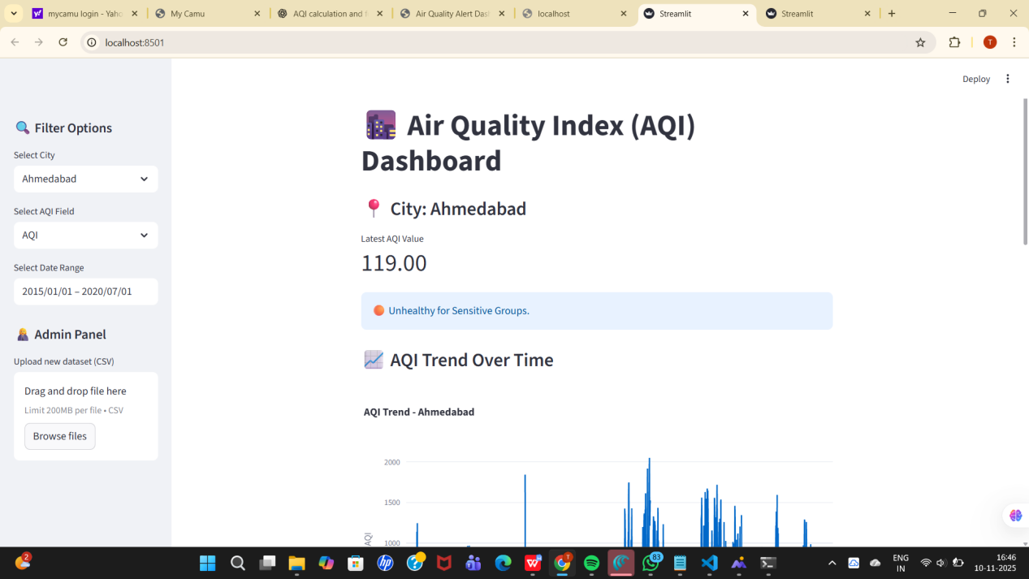

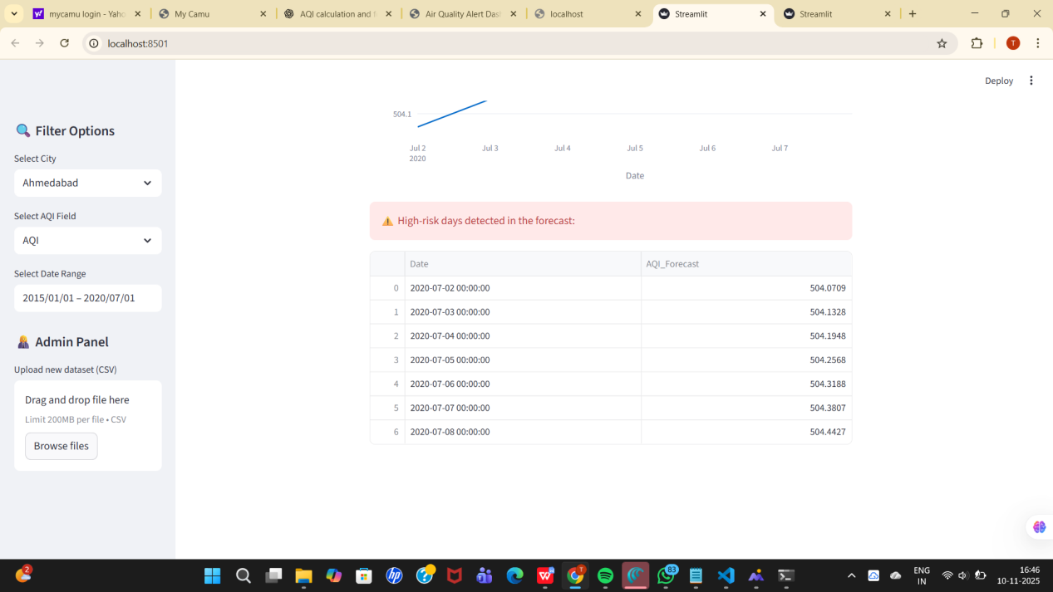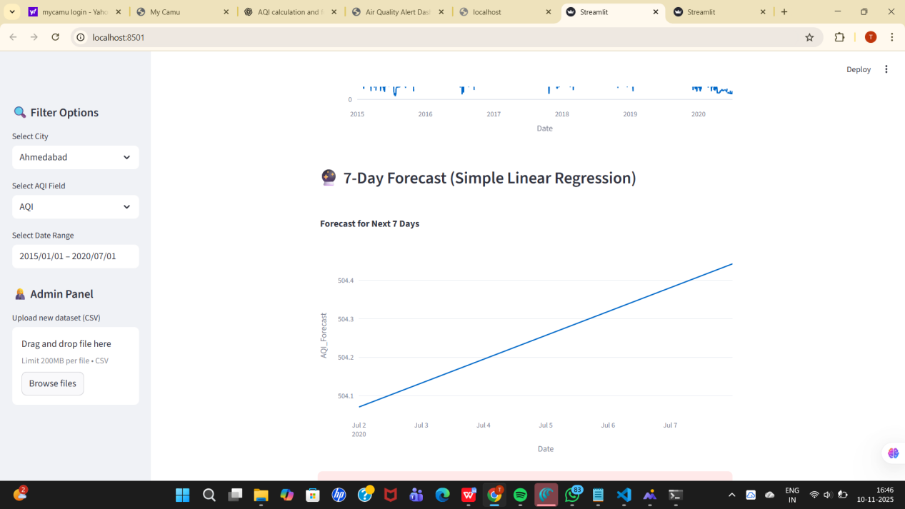
A DASHBOARD CONTAINING ALL 4 MODULES:

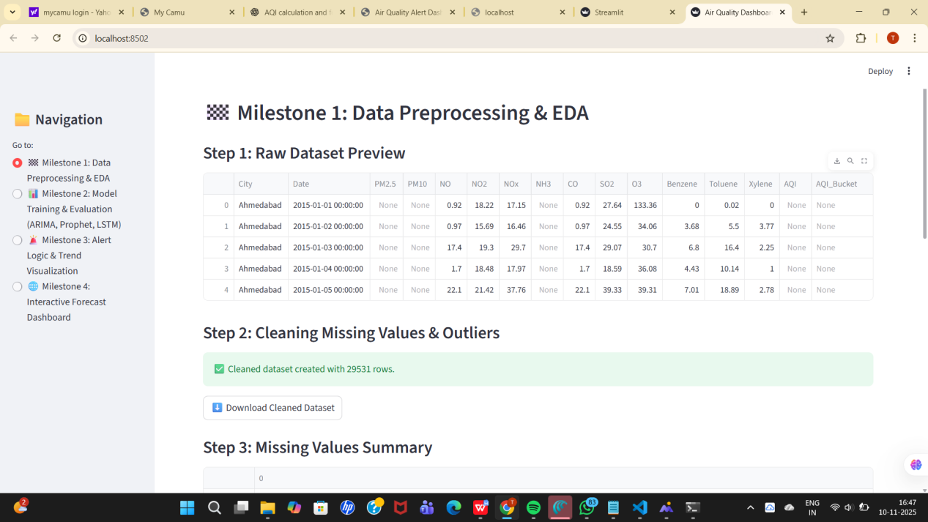
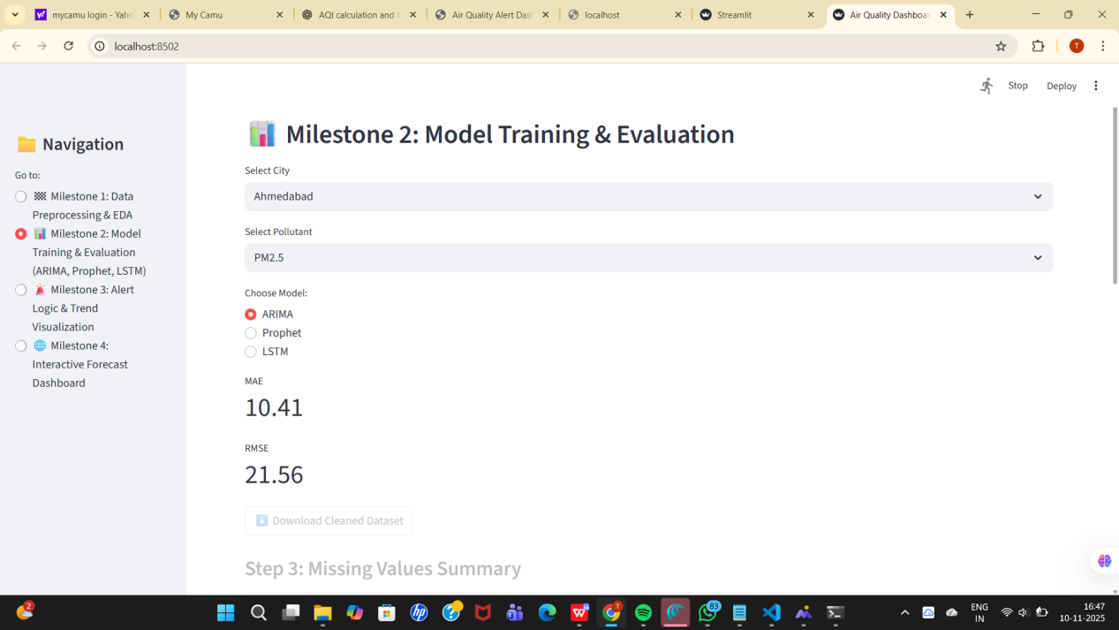

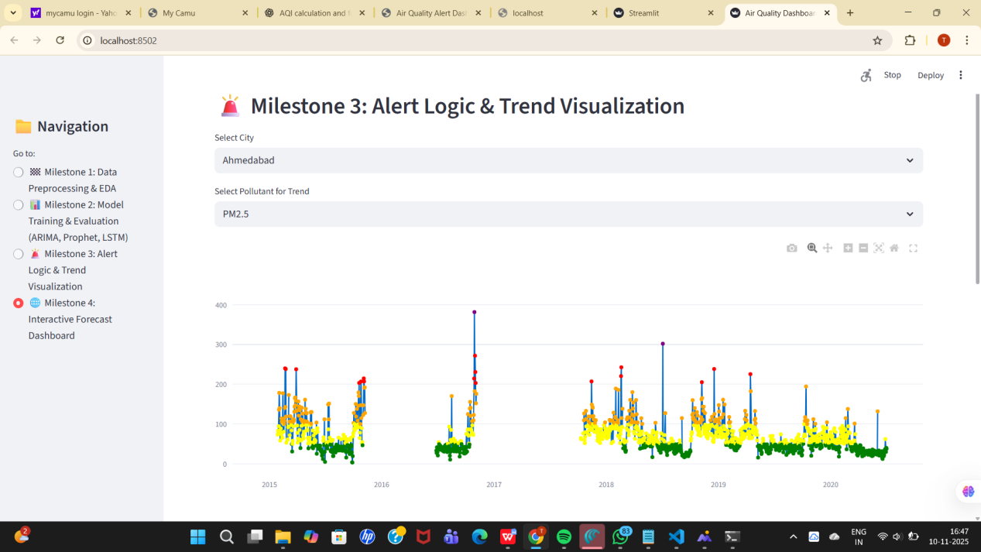
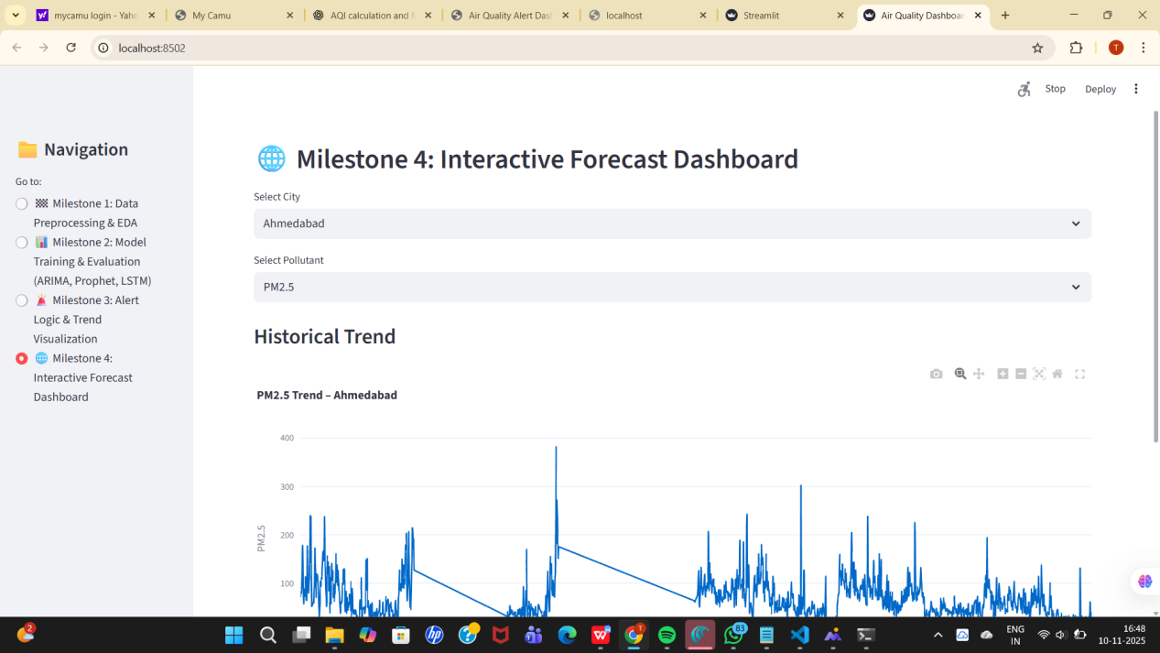

Steps to Run the Project
Run Locally on VS Code :
1.Install Python (v3.9 or higher): Download from https://www.python.org.
2.Install Dependencies: Open Command Prompt or VS Code Terminal in your project folder and run:
“pip install pandas numpy matplotlib seaborn plotly scikit-learn statsmodels prophet tensorflow streamlit “
3.Place Dataset:Copy your dataset file (e.g., city_day.csv) into the project folder.
4.Run the Streamlit Dashboard In terminal:
“streamlit run main_dashboard.py “
5.View in Browser :Streamlit will open automatically, or visit:http://localhost:8501

How the Project Works to Solve the Problem:
Data-Driven Decision Support: The system uses historical pollution data (like CO, NO₂, SO₂, PM2.5, PM10, etc.) to identify trends and patterns that affect AQI levels. This helps in understanding pollution behavior across time and locations.
Accurate Forecasting Using ML Models: Through ARIMA, Prophet, and LSTM models, the system forecasts future AQI and pollutant levels. These forecasts provide early warnings about possible air quality deterioration — enabling proactive actions by environmental agencies.
Interactive Visualization via Streamlit: The Streamlit dashboard makes complex data easy to interpret. Users can select pollutants, cities, or date ranges and instantly see trends, alerts, and predictions — turning raw data into actionable insights.
Public Awareness and Health Safety: By presenting clear and visual forecasts, the project empowers citizens to plan outdoor activities, use air purifiers, or take preventive steps during high pollution periods.

Future Enhancements
While the project successfully predicts air quality and pollutant levels, there are several meaningful enhancements that can make it more powerful and real-time in the future.
1. Integration with Real-Time IoT Sensors: Connect the dashboard to IoT-based air quality sensors to fetch live data instead of relying on static CSV files.
This would help in real-time AQI monitoring and alert generation.
2. Advanced Deep Learning ModelS: Implement hybrid deep learning models (like CNN-LSTM or Transformer models) for higher prediction accuracy.
These models can learn spatial as well as temporal pollution patterns.
3. Mobile App or Web Deployment: Deploy the dashboard as a mobile or web application (using Streamlit Cloud, AWS, or Flask) to make it accessible to the public and authorities on the go.
4. Geo-Mapping and Location-Based Alerts :Integrate with Google Maps API or Folium to visualize pollution on a map with color-coded markers.

GITHUB LINK: https://github.com/Ch-Ramya03

